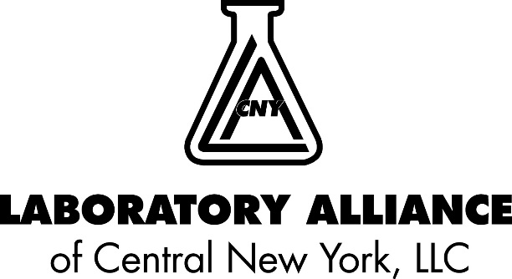

To: Healthcare Providers

From: Bodhraj Acharya, PhD, FAACC
Manager, Chemistry and Referral Testing

Date: August 18, 2021

Re: Lactic Acid Assay (LAC) – Kit Supply Shortage

We were notified by our vendor that the Lactic Acid test kit for our Siemen’s Vista chemistry analyzers is temporarily unavailable due to a raw material shortage. The vendor anticipates that the kit will become available in late September.

Effective Thursday, August 19, 2021 at 10:00 AM, whole blood lactic acid testing will be performed at our St. Joseph’s Health and Crouse Health Rapid Response Laboratories (RRL) on the Nova pHOX analyzer. Specimens from our Outreach clients will be delivered by stat courier to one of the RRLs for testing. The order code in Soarian, Epic and client EMRs will remain the same. The order will be updated to Whole Blood Lactate (WBLAC) when the specimen arrives in the lab.

It’s important to note the change in specimen type to dark green top lithium or sodium heparin whole blood tube. Specimens collected in a gray top sodium fluoride/potassium oxalate tube are not acceptable.

Test Code | LAC - No change
Reference Range | 0.7 – 2.5 mmol/L
Reportable Range | 0.3 – 20.0 mmol/L
Specimen Requirement | Dark green lithium or sodium heparin whole blood tube
Storage and Transport | Room temperature
Stability | TIME SENSITIVE. Collect specimen without tourniquet. Specimen must be transported to laboratory within 15 minutes of collection.
Unacceptable conditions | EDTA, citrate, oxalate and sodium fluoride anticoagulants are not acceptable.

Please direct any questions regarding this matter to Bodhraj Acharya, Ph.D. FAACC at 315-410-7028 or BodhrajAcharya@lacny.com.

